Standard Operating Procedure
Methylene Chloride (Dichloromethane)

Department: [Insert Department]
Principal Investigator: [Insert PI Name]
Office Phone: [Insert Office Phone Number]
Office Location: [Insert Office Building and Room Number]
Laboratory Manager: [Insert Lab Manager’s Name]
Lab Phone: [Insert Lab Phone Number]
Research Start Date: [Insert Date: mm/dd/yyyy]
Expected Length of Research (months): [Insert months]
Date SOP Was Written: [Insert Date: mm/dd/yyyy]
SOP Version Number: [Insert version number]
Date of Latest Revision: [Insert Date: mm/dd/yyyy]
Sections Revised/Modified: [Insert specific sections]

Note: This SOP must be completed, signed, and dated by all relevant lab personnel. It fulfills the requirements of the EPA’s Workplace Chemical Protection Program (WCPP) for methylene chloride. The SOP also replaces the need for a separate PHS Request Form; completing this SOP satisfies the WCPP and PHS request requirements.

Scope
Add the information about re-PHS approval.
This Standard Operating Procedure (SOP) provides a template for laboratories using methylene chloride in research at the University of Arkansas, Fayetteville (UA). It is designed to comply with the 2024 Environmental Protection Agency (EPA) Final Rule under the Toxic Substances Control Act (TSCA) Section 6(a).

Responsibilities
Principal Investigator (PI)
- Ensure all procedures outlined in this SOP are implemented and followed.
- Maintain an accurate chemical inventory in SciShield.
- Review and update this SOP annually or whenever procedural changes occur.
- Ensure ENHS is contacted if:
  - A spill, exposure, or safety concern arises.
  - Processes involving methylene chloride change (e.g., volume, frequency, location).
Lab Personnel
- Read and understand this SOP and the chemical-specific Safety Data Sheet (SDS) prior to handling methylene chloride.
- Complete all required training, including refresher training when applicable.
- Use only designated areas and fume hoods approved for methylene chloride work.
- Don required PPE before beginning work.
- Follow all procedures outlined in this SOP.
- Participate in baseline or follow-up air sampling as directed by ENHS.
- Immediately report any spills, exposures, or equipment malfunctions to the PI and ENHS.

Chemical Overview
Chemical Abstract Service (CAS) Number
- 75-09-2.
Chemical Properties
- Clear, colorless liquid with a chloroform-like odor.
Hazards
- Probable human carcinogen; Central Nervous System (CNS) depressant; Irritant (respiratory, skin, and eye).
Routes of Exposure
- Inhalation (primary), dermal absorption, and eye exposure.
EPA Exposure Limits
- 8-hour Time Weighted Average (TWA): 2 parts per million (ppm).
- Action Level: 1 ppm (8-hr TWA).
- 15 Minute Short-term Exposure Limit (STEL): 16 ppm.

Designated Use Areas
Methylene chloride will be used only in designated areas that meet the following criteria:
- Access must be limited to trained and authorized personnel during active use.
- If methylene chloride is used outside of a fume hood (e.g., benchtop), the user must physically demarcate the work area (e.g., tape).
- Prior to work starting, users must post warning signage (see Appendix A) to clearly identify the designated use area.
- The PI will ensure designated areas are maintained in a clean, controlled, and access-restricted condition.
- List all designated use areas: [Insert all designated use areas here (e.g., CHEM 328, Fume Hood 123456)].

Personal Protective Equipment
Prior to any methylene chloride use, personnel must don the PPE below:
Body
- [Insert body PPE here (e.g., chemical-resistant lab coat, long pants, and closed-toe shoes)].
Eye/Face
- [Insert eye PPE here (e.g., splash protection goggles)].
Note: Full-Face Air Purifying Respirator with Organic Vapor P100 Cartridges will be required if working outside a fume hood and air sampling exceeds the action level (1 ppm) or the STEL (16 ppm).
Hands
- [Insert hand PPE here (e.g., Silver Shield inner gloves with nitrile outer gloves for abrasion protection].
Note: Silver Shield or equivalent multilaminate chemical-resistant gloves must be worn as the primary barrier against methylene chloride. These gloves must be layered underneath a pair of disposable nitrile gloves, which serve only as outer protection against mechanical damage or punctures.
Note: According to manufacturers and chemical compatibility data, nitrile, butyl, neoprene, and latex gloves offer poor resistance to methylene chloride and must not be used as the primary protective barrier.

Air Monitoring (WCPP Requirement)
Air monitoring for methylene chloride is required as part of the WCPP. Baseline monitoring will be conducted by the University Industrial Hygienist. Additional monitoring may be required if:
- Procedures change significantly (e.g., increased volumes, frequency, or new equipment).
- Symptoms or exposures are reported.
- If baseline monitoring exceeds the 1 ppm action level or 16 ppm STEL.
Note: All air monitoring will be performed by ENHS. Laboratories are not permitted to conduct independent sampling under the EPA rule.

Detailed Procedures
[Insert detailed procedures that describe the process from start to finish]

Training
The PI will ensure training is completed in the following areas prior to any user beginning work with methylene chloride:
- This SOP, the manufacturer specific SDS (including all specific hazards).
Note: It is the PIs responsibility to ensure all laboratory personnel have received all appropriate training, are current with any necessary refreshers, and sign the Training Log (Appendix B). The training log must be maintained with this document in the lab.

Storage and Handling
- All users will ensure containers are tightly closed and kept upright.
- Users must use secondary containment for all handling and storage (stocks and waste).
  - Polyethylene (HDPE/LDPE) has poor chemical compatibility and is not recommended for prolonged contact with methylene chloride.
  - Polyetrafluoroethylene (PTFE) provides the best chemical resistance.
- [List all storage locations, container size and quantity]
- [Describe what secondary containment will be used for handling containers and storing containers]

Waste Management
- Label all methylene chloride waste containers as “Methylene Chloride (include additional constituents and percentages (e.g., Dichloromethane 50%, Water 50%) (see Appendix C for an example).
- Store all hazardous waste in designated Satellite Accumulation Area (SAA) [insert SAA number] inside fume hood [Insert fume hood asset tag number].
- When ready for pickup, complete a Hazardous Waste Pick Up Request form and email the completed form to enhs@uark.edu.

Emergency Information
Spill Inside Fume Hood
Users may safely clean up any spill that occurs entirely within a chemical fume hood that can be safely cleaned up using the chemical spill supplies immediately available in the lab. If the spill exceeds the user’s ability or supplies are exhausted, shut the sash and contact ENHS at 479-575-5448.
Note: The responder must be trained, wearing required PPE, and confident that the spill presents no risk of exposure.
Spill Outside Fume Hood
Users will not attempt to clean up a spill that occurs outside of a fume hood. If a spill occurs, everyone in the lab must evacuate and immediately contact ENHS at 479-575-5448.
First Aid Measures
- If Inhaled: Move into fresh air and seek medical attention at Pat Walker Health Clinic or Washington Regional Medical Center Emergency Room.
- Skin Contact: Immediately remove contaminated clothing and rinse the skin thoroughly using the safety shower in lab [list the lab room number].
- Eye Contact: Remove contacts if present and rinse with water using the eye wash in lab [list the lab room number] for 15 minutes.
Note: If seeking medical attention, take the SDS with you to the facility and provide it to the medical personnel during evaluation.

Recordkeeping
The PI will ensure the following records are maintained in the lab with this SOP:
- Baseline and follow-up air monitoring reports provided by ENHS.
- Training logs (Appendix B).
- Safety Data Sheet.
Note: ENHS will maintain the official air monitoring schedule and archive of sampling results. Laboratory copies are required to remain with this SOP for inspection and audit readiness.

Signatures
PI: _______________________________________________ Date: __________________________
Lab Manager: _____________________________________ Date: ___________________________

This SOP fulfills the requirements of the 2024 EPA Final Rule on Methylene Chloride (40 CFR Part 751, Subpart B) and the University of Arkansas' implementation of the Workplace Chemical Protection Program.

Appendix A, Warning Sign
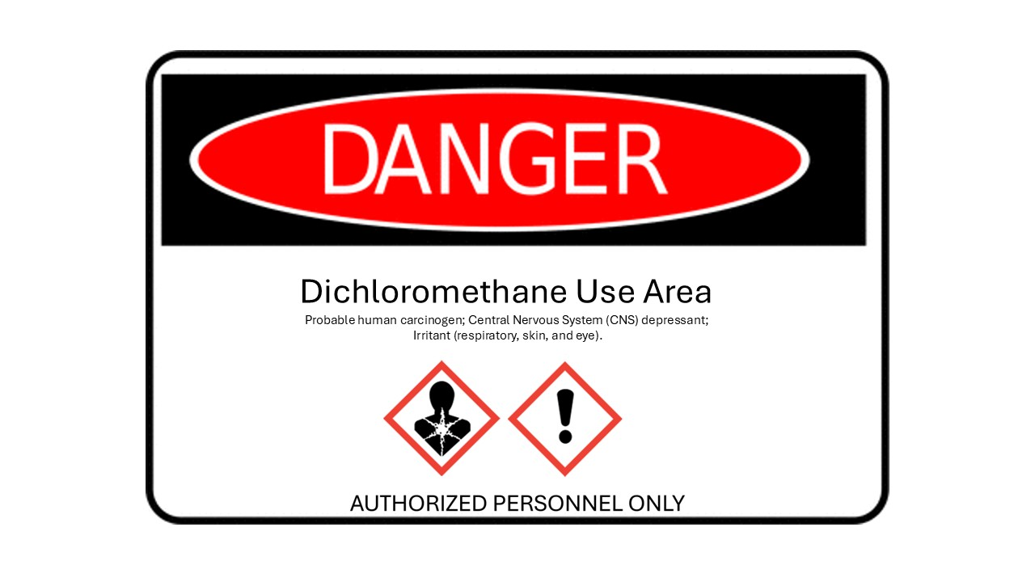

Appendix B, Training Log
Lab Personnel (Print and Sign)
Name: __________________________________________________________ Date: ________________
Name: __________________________________________________________ Date: ________________
Name: __________________________________________________________ Date: ________________
Name: __________________________________________________________ Date: ________________
Name: __________________________________________________________ Date: ________________
Name: __________________________________________________________ Date: ________________
Name: __________________________________________________________ Date: ________________
Name: __________________________________________________________ Date: ________________
Name: __________________________________________________________ Date: ________________
Name: __________________________________________________________ Date: ________________
Name: __________________________________________________________ Date: ________________
Name: __________________________________________________________ Date: ________________
Name: __________________________________________________________ Date: ________________
Name: __________________________________________________________ Date: ________________
Name: __________________________________________________________ Date: ________________
Name: __________________________________________________________ Date: ________________
Name: __________________________________________________________ Date: ________________
Name: __________________________________________________________ Date: ________________
Name: __________________________________________________________ Date: ________________

Appendix C, Hazardous Waste Label Example
Label must be affixed to the container without obscuring the original manufacturer label. If the hazardous waste label is too big for the container, put the container into a Ziploc (slider) bag and affix the waste label to the outside of the bag.

