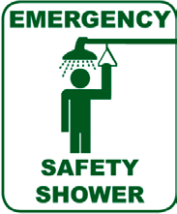
Emergency Shower Station
Weekly Inspection Checklist
How to obtain assistance:
Questions, maintenance requests, training information
Environmental Health and Safety: 5-5448

Maintenance requests may also be called in directly
Service Desk: 5-5050
Facilities Services (Zone Maintenance): Zone A: 5-3730
Zone B: 5-6173 Zone D: 5-3414 Zone E: 5-2968
Zone F: 5-7354

Emergencies:
Immediately stand in the water stream and flush the affected area for 15 minutes. Remove contaminated clothing while showering and not before. CALL 911 and seek medical assistance.
How to Test:
- Is access to the shower free of obstructions from all areas of the laboratory or hallway?
- Place a 5-gallon bucket underneath the safety shower and a shower curtain around the shower head and inside the bucket to catch all the water (Note: the shower will produce 20 gallons/minute)
- Evaluate for adequate flow
- Does the water continue to flow until the pull handle is turned off?
- Is the plumbing free from leakage?

Date | Initials | Comment |  | Date | Initials | Comment |  | Date | Initials | Comment

